

Vaccination coverage survey for children aged

six months to nine years in

Béboto District, Logone Oriental, Chad

Final Report

Date: April 2020

Julia Sohn, MPH

*Summary*

***Study design***  Cross-sectional survey

***Sampling strategy*** Two-stage cluster sampling

***Study participants*** Children 6 months – 9 years

***Study period*** April 2020

***Study site***  Béboto District

***Study team***

|  |  |  |
| --- | --- | --- |
| **Name** | **Title and affiliation** | **Role in survey** |
| Julia Sohn | Field epidemiologist, Chad Emergency Response Unit (CERU), MSF-OCA | Principal investigator |
| Patrick Keating | Epidemiology advisor, Manson Unit, MSF-OCA | Co-investigator, study coordinator |
| Susan Doyle | Project coordinator, CERU, MSF-OCA | Co-investigator |
| Allafi Bow Gamaou | CERU Data manager, CERU, MSF-OCA | Co-investigator |
| Seidina Ousseini | Head of mission, Chad, MSF-OCA | Co-investigator |
| Winston Katuta Mulanda | Medical coordinator, Chad, MSF-OCA | Co-investigator |
| Lucia Ringtho | Health Advisor, MSF-OCA | Co-investigator |

***Collaborating institutions*** Ministry of Health, Chad

## EXECUTIVE SUMMARY

**Background**

Chad is a large country in north-central Africa, with a population of approximately 15.95 million (2019). Measles in Chad is endemic and very low vaccination coverage puts children, especially those under five, at risk of infection, comorbidities, and death. The last national measles mass vaccination campaign in Chad occurred 2015, and according to UNICEF survey results in 2017, overall immunization coverage in the country is only 37%.

In Béboto district, Logone Oriental province, Chad, a steady increase in measles cases began in 2019. This started with a spike in late 2019, rising from 10 cases in week 45 to 38 cases in week 46. Although there have been supplementary immunization activities in several districts in Logone Oriental province in previous years (2012, 2014, 2015, 2016, 2017), target populations and coverage are not well reported in Béboto. In response to the surge in cases, Médecins Sans Frontières (MSF) undertook a vaccination campaign that targeted children aged 6 months to 9 years of age in the 13 health zones of Béboto district. The campaign took place from March 23-April 1, 2020. Directly afterward, MSF conducted a vaccination coverage survey to determine whether the campaign had reached the target number of children and achieved herd immunity.

**Methods**:

The vaccination coverage survey used two-stage cluster sampling methodology as an adaptation of the standardized method recommended by the World Health Organization (WHO). Determination of vaccine status was done by interview, examination of individual vaccination cards, recent vaccine ink markings of fingers (if evidence of marking persisted), and verbal reporting of vaccination status.

This coverage survey used descriptive statistics to describe the study population. Weighted vaccination coverage rates were calculated for measles vaccination. Reasons for non-vaccination were described, and overall immunity of the target population was calculated.

**Results**:

985 children aged 6 months to 9 years were included in the survey. MSF vaccination coverage was 95.8% (95% CI: 93.0–97.5), routine coverage was 45.4% (95% CI: 35.0–56.1), while SIA coverage was 48.0% (95% CI: 38.3–57.8). The overall measles vaccination coverage in Béboto district was 98.1% (95% CI: 96.3–99.1), and the assumed immunity status (those who ever received a measles vaccination or were ever infected with measles) was 98.7% (95% CI 97.5–99.4).

The primary reasons for non vaccination during the MSF campaign was that the family was out of town (n= 39, 83.0%). For routine vaccination, the most common reason for non vaccination was that the family was not aware the child should be vaccinated against measles at 9 months (n=209, 50.1%). For other supplementary immunization activities (SIA), the primary reason for non vaccination was that the child was too young or not yet born when a campaign took place (n=187, 49.6%).

**Conclusion**:

Overall coverage prior to MSF vaccination was quite low, but the March 2020 campaign achieved 95.8% coverage, ensuring herd immunity for the population aged 6 months to 9 years. However, the lack of knowledge about routine vaccination as well as few or irregular supplementary immunization activities put the population at risk of future outbreaks.

Recommendations

* Routine vaccination is an essential milestone, especially given persistent measles outbreaks across Chad. Yet, the population of Béboto was overwhelmingly unaware of the need to take their child for a routine vaccination at 9 months. Improved and widespread sensitization activities are recommended, taking care to reach those who are likely to give birth at home.
* Chad’s EPI activities need to be improved, as coverage before the MSF vaccination response in Béboto only offered protection to approximately 50% of the population aged 6 months to 9 years; far below the level required for herd immunity. More frequent SIAs are required, as most respondents reported that their child was too young or had not yet been born when the last SIA campaign occurred in Béboto.
  + .
  + An important step to improving EPI is understanding where the gaps and weaknesses lie. An evaluation of the ministry of health’s immunization program is suggested to identify areas for improvement (e.g. supply chain, cold chain, transport, human resources).

Table of Contents

EXECUTIVE SUMMARY 3

List of abbreviations 6

1. Introduction 8

1.1. Country Information 8

1.2. Measles outbreakin chad 9

2. Rationale 9

3. Vaccination coverage survey Objectives 11

3.1. Primary objectives 11

3.2. Secondary objectives 11

4. METHODS 11

4.1. STUDY Design 11

4.2. Target population 11

4.3. Inclusion and exclusion criteria 11

4.4. Definitions 12

4.5. Vaccination definitions 12

4.6. Sample size and sampling 13

4.7. Sampling procedure 13

4.8. Data collection 15

4.9. Data Management and AnalysIS 15

4.10. Ethical Principles 16

5. RESULTS 16

5.1. Study Sample 16

5.2. Demographic information: 17

5.3. Vaccination coverage – MSF Vaccination Campaign 18

5.4. Reasons for non vaccination (MSF) 19

5.5. Vaccination coverage – routine Vaccination (9 months) 19

5.6. Reasons for non-vaccination (routine) 20

5.7. Vaccination coverage – supplementary vaccination activities (SIA) 20

5.8. Reasons for non-vaccination (SIA) 21

5.9. overall measles vaccination coverage 22

5.10. Number of doses 22

5.11. Previous measles infection 23

6. Discussion 24

6.1. limitations 25

7. Recommendations: 26

## List of abbreviations

EPI Expanded Programme of Immunization

95% CI 95% confidence interval

MVC Mass Vaccination Campaign

MSF Médecins sans Frontières

MSF-OCA Médecins sans Frontières - Operational Centre Amsterdam

PPS Probability proportional to size

SIA Supplementary Immunization Activities

VCS Vaccination coverage survey

WHO World Health Organization

UNICEF United Nations Children's Fund

**ACKNOWLEDGEMENTS**

We would like to thank the Ministry of Public Health of Chad for the permission to undertake this survey, and the population the Béboto district for their participation, assistance and cooperation during this survey.

## Introduction

### Country Information

Chad is a large country in north-central Africa, with a population of approximately 15.95 million (2019)[1]. The country is divided into 23 regions; each region is further divided into districts. Based on the 2019 estimates of the Human Development Index, Chad is ranked 187 out of 189 countries. Life expectancy at birth is 53 years for men and 55 years for women. The under-five mortality rate is 123/1,000 live births.[2]

**Figure 1**. Map of Chad (yellow).

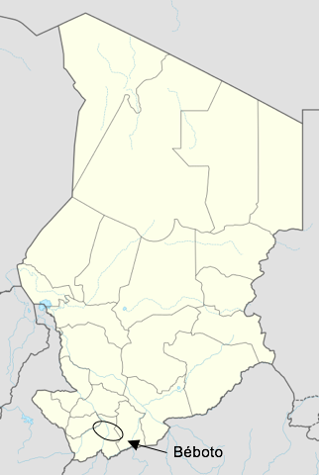

**MSF presence**

MSF-OCA has been present in Chad since 2003. The mission includes an emergency project, Chad Emergency Response Unit (CERU), which provides rapid response in case of an emergency. From 2010 to November 2018, MSF ran a project in Am Timan, Salamat, supporting Am Timan Hospital in internal medicine, TB/HIV programs, general paediatrics, nutrition, maternity, and neonatal services.

### Measles outbreakin chad

Measles in Chad is endemic and very low vaccination coverage puts children, especially those under five, at risk of infection, comorbidities, and death. Despite Chad's efforts in the field of immunization, routine coverage surveys show that immunization coverage in the country is very low and does not ensure the collective immunity of children under five. The last national measles mass vaccination campaign in Chad occurred 2015 and according to UNICEF survey results in 2017, overall immunization coverage in the country is only 37%.

Measles season begins in March (halfway through the dry season) and usually ends in June (start of the rainy season). However, in previous years, there was not a clear end to cases, only a reduction; measles cases continue to appear year-round.

## Rationale

Although there have been supplementary immunization activities in several districts in Logone Oriental province in previous years (2012, 2014, 2015, 2016, 2017, & 2019), target populations and coverage are not well reported in Béboto. In 2019, there were additional vaccination campaigns of certain districts, but Béboto was not included.

Based on routine surveillance data from the Ministry of Health (MoH), a steady increase in measles cases began around epi week 50 in 2019, climbing from 11 to 14 to 26 cases in weeks 50, 51, and 52 respectively. Cases continued to climb, and nearly doubled from week 2 to week 3, 2020 (from 23 cases to 41). MSF made the decision to visit Béboto district and evaluate the alert.

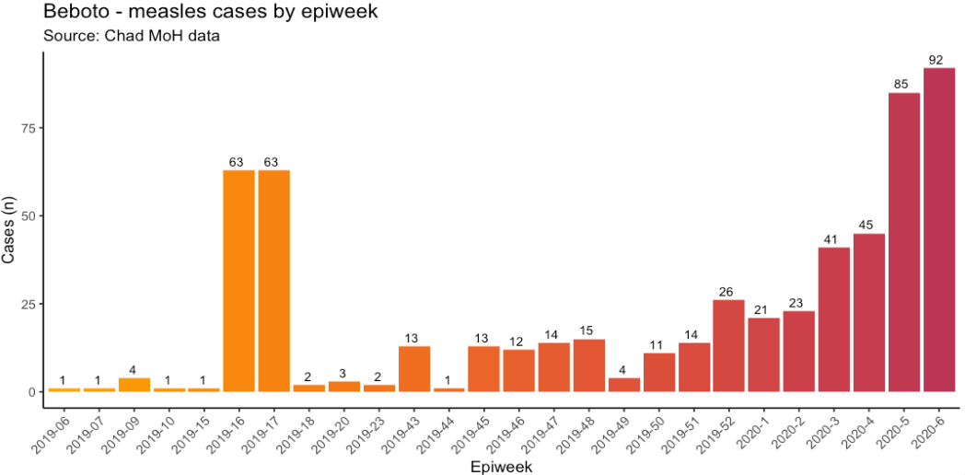

The data that MSF collected in the field from the health centre records also reflects an alarming trend, beginning with a spike in week 46 of 2019, rising from 10 cases in week 45 to 38 cases in week 46. While the numbers MSF collected do not correspond exactly with what the MoH reported, both sources indicated the need for a response.

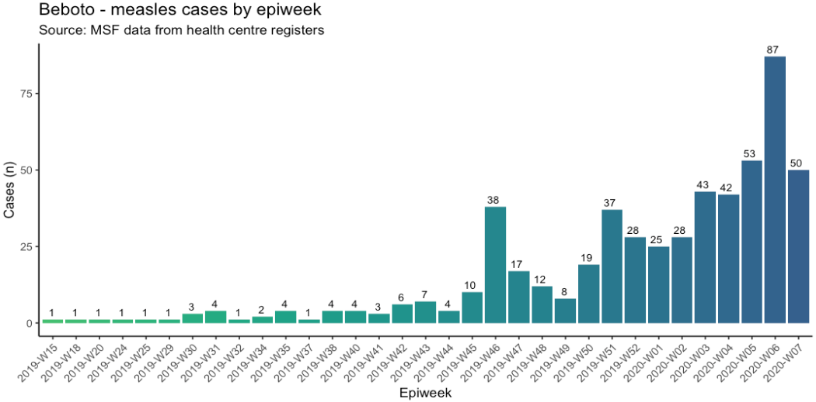

MSF decided to intervene in Béboto for the following reasons:

* Measles is a disease with epidemic potential and a high transmission rate; Béboto district had already seen a doubling of cases.
* The population lacks access to free, high-quality health care, and there are no health actors in the region except for the MoH.
* The MoH did not have sufficient vaccines nor sufficient financial, logistic, or human resource capacity in Béboto to run a vaccination campaign.
* Béboto was not included in the Ministry’s outbreak response (supported by UNICEF/WHO).

MSF’s intervention had six objectives:

1. Identify the most affected locations, assess measles patients’ accessibility to health care, and make measles treatment kits available
2. Support MoH with direct case management (simple & complicated) free of charge
3. Organize trainings on measles case management for MoH staff in Béboto Hospital and in the health centers before providing treatment kits
4. Reinforce the surveillance system in the district (establishment of a line list and improved data collection) & awareness raising in the community for active case finding
5. Plan a mass vaccination campaign to improve vaccination coverage in the district for the population aged 6 months to 9 years
   * This age group was targeted based on the age distribution of early cases; children aged 6 months to 9 years were most heavily affected.
6. Advocacy for improved routine immunization and healthcare in the district by the MoH and their key partners (WHO, UNICEF)

Related to objective five, MSF conducted a measles mass vaccination campaign targeting children between 6 months and 9 years of age in Béboto in March 2020. Immediately following the campaign, MSF conducted a vaccine coverage survey to estimate the vaccination status in the target age group.

## Vaccination coverage survey Objectives

### Primary objectives

Estimate the measles vaccination coverage among children 6 months to 9 years of age in Béboto district following the MSF mass vaccination campaign.

### Secondary objectives

* Estimate the overall measles vaccination coverage among children 6 months to 9 years of age in Béboto district
* Describe the reasons for non-vaccination during immunization activities
* Provide recommendations for vaccination strategies and surveillance in this   
  context and similar ones

## METHODS

### STUDY Design

The vaccination coverage survey used two-stage cluster sampling methodology as an adaptation of the standardized method recommended by the World Health Organization (WHO).[3]

Determination of vaccine status was done by interview, examination of individual vaccination cards, recent vaccine ink markings of fingers (if evidence of marking persists), and verbal reporting of vaccination status.

The survey took place over six days, from April 1-6, 2020.

### Target population

All children between 6 months and 9 years of age living in Béboto district during the time of the survey.

### Inclusion and exclusion criteria

Households were included in the survey if they satisfied all of the following criteria:

* At least one child between 6 months and 9 years of age living in the selected household.
* At least one adult (over 18 years old) present on the day of visit who was able to comment on the vaccination status of the children in the household.

Persons were excluded from the survey if they satisfied one of the following criteria:

* Refusal to participate in the survey (persons themselves or their parent/guardian/caretaker).
* Inability to locate an adult who stays in the household.

### Definitions

#### HOUSEHOLD DEFINITIONS

*Definition of household*

A household was defined as a group of people under the responsibility of one person or head of household. All members of the household meeting the age inclusion criteria were included, no matter the relation with the other members.

*Definition of head of household*

The head of household was defined as follows:

* Adult household member ≥ 18 years, *and*
* Can give accurate information on all demographic issues in his/her  
  household *and*
* Self-identified as the head of household, *and*
* Was present at the time of the survey

If an official head of household was absent at the time of the survey, study interviewers inquired if any other caretaker in the household was present at the time of the survey, was able to provide consent for the household, and was able to give accurate information. A household was excluded from the survey if none of the household members fulfil all these criteria.

### Vaccination definitions

The survey looked at vaccination coverage after MSF’s mass vaccination campaign, as well as the overall vaccination coverage in Béboto district. The latter includes vaccination through routine expanded programme on immunization (EPI) activities, previous supplementary immunization activities, or other mass vaccination campaigns.

* Vaccinated by card
  + An individual who received one (or more) doses of measles-containing vaccine. This is confirmed on interview by presentation of a vaccination card.
* Vaccinated by verbal confirmation
  + An individual who received one (or more) doses of measles-containing vaccine. This is confirmed on interview by verbal history of the participant or his/her parents/guardians/caretakers or by a marked finger, but without presentation of vaccination card.
* Not vaccinated
  + An individual who did not receive one dose of measles-containing vaccine, does not have a vaccination card demonstrating such, nor has any finger marking suggesting vaccination took place. This is confirmed on interview by the participant or his/her parents/guardians/caretakers stating that no measles vaccination was received.
* Unknown
  + An individual or his/her parents/guardians/caretakers do not recall if the survey participant was vaccinated AND there is no marking of the finger suggesting that the vaccination took place, nor any other available proof (e.g. health passport).

### Sample size and sampling

#### SAMPLE SIZE CALCULATION[4]

The sample size was calculated using ENA SMART software (SMART, 2015) based on the following criteria:

* Average household size of 6
* 36% of children aged 6 months to 9 years
* Estimated coverage of 85%
* Confidence intervals of 95%
* Precision of 5%
* Design effect of 2.5
* Non response rate of 10%

This returned a sample size of 533 children in 305 households (a total of 31 clusters of 10 households). However, in order to account for clusters that may not be accessible, we added 2 additional clusters as backups, bringing the total to 33. To calculate these supplementary clusters, we called or visited each health centre responsible in the 13 health zones and asked which villages in their zone were not accessible by vehicle. We then calculated the total proportion of villages in the district that may be inaccessible, and inflated the total number of clusters by that proportion. Teams planned to visit all 33 clusters, but if they found that one is inaccessible, they would skip that cluster and not replace it.

### Sampling procedure

A two-stage cluster sampling methodology was used as an adaptation of the standardized method recommended by the WHO. In the first stage, 33 clusters were selected from all villages based on probability proportional to population size (PPS), using available population data from 13 regional health facilities.

For the second stage, MSF used the 2005 standard WHO/EPI methodology (random walk) to select 10 households per cluster. To do so, a pen was thrown on the ground in the central point of the village (as identified by the village chief), and an imaginary line was drawn in its direction towards the edge of the village. The team walked in the direction of the pen until the edge of the village was reached. To prevent centre bias, the team repeated this process from the edge of the village: they threw the pen again and walked in the direction of the pen until another edge of the village was reached. This time, the team counted houses as they went, getting permission to subtly mark each household with chalk to note the number it had been assigned. Once the edge of the village was reached, one of the houses along the imaginary line was selected using either “random number generator” or “nombre aléatoire”, applications that had been downloaded to every tablet.

The selected house was the first to be interviewed in the cluster. The next household following in order of physical proximity was then interviewed until the desired cluster of 10 households was completed. Physical proximity was defined as being the household whose front door is closest to the front door of the household that was just interviewed. If more than one house could be selected, teams chose the house to the right as they stood looking out of the doorway of the household just interviewed.

If teams encountered any of the following situations, they followed the steps outlined below:

* If all households of a selected village were included in the study before completing the required number of households, the cluster would be continued by selecting the (geographically) closest village. The chosen sampling methodology would again be used in the closest village to select the first household in the village.
* If a household refused to participate in the survey, it would not be replaced by another household in the cluster.
* If a household did not have any children aged 6 months to 9 years, it would be replaced by another household in the cluster.
* If a household was empty, surveyors would return one more time; if it wasn’t possible to interview that household, they would replace it with the next closest household in the cluster.
* If no one was available in a household to provide consent at the time of the visit, the surveyors would inquire when that person is expected to return. If the person would return within the timeframe that the team was in the village, they would return to request an interview. If the person who could provide consent would not return during the time the team planned to be in the village, the team documented this and replaced the household.

All children in the eligible age range in the identified households were included in the survey, including in the final household of a cluster, even if this exceeded the total target of children for the cluster.

### Data collection

Data collectors used KoBoCollect software on tablets during face-to-face interviews with household heads. In the households selected, the interviewing team explained the purpose of the survey to the head of the household/survey participant or the parents/guardians/caretakers in the language he or she was familiar with, and verbal consent was obtained to conduct the interviews and documented on the questionnaire. All refusals were recorded to document participation rate.

A standardized pre-piloted questionnaire was used to collect the following data for each child of the cohort at recruitment:

* Demographic data: age, sex, number of children in the household
* Vaccination status: verbal and card confirmation
* Reasons for non-vaccination
* Previous measles infection

In addition, information on the number of households visited, number of empty households, number of households interviewed, and number of refusals was collected using tablets, with paper forms to help teams remember which houses to return to.

### Data Management and AnalysIS

Databases were automatically generated from the data entry in the tablets at the time of the interview. During the survey, data monitoring was conducted daily to check for inconsistencies in data entry and responses.

The main outcome of the analysis was the vaccination coverage in Béboto district among children aged 6 months to 9 years following the MSF vaccination campaign. Secondary outcomes were the vaccination coverage of children aged 6 months to 9 years from other vaccination activities (i.e. routine vaccination and supplementary vaccination activities), and the reasons for non-vaccination.

Data cleaning and analysis were conducted using the R4Epis Vaccination Coverage Survey template and the software R 3.6.2 (2019-12-12). Our sample size required 31 clusters but we increased this to 33 to account for any problems accessing clusters. We ultimately excluded one of the 33 clusters as the selected cluster was a nomadic village and the village had moved on when the team arrived.

Only households with children of eligible age (6 months to 9 years) were included in the analysis. The study population’s age and sex distribution were described, and weighted coverage estimates for MSF mass vaccination, routine vaccination, SIA vaccination, and overall vaccination coverage were calculated. Reasons for non-vaccination were described. Reasons that were classified as “other” with a free text option were reclassified into new categories based on theme. The number of children with a previous previous measles infection were also described and the overall immunity of Béboto population was estimated.

Overall vaccination coverage was calculated by combining all three vaccination opportunities into one variable. Immunity for the population was calculated by combining children who had either already been vaccinated or had been previously infected with measles.

### Ethical Principles

The survey was conducted in accordance with the Council for International Organisations of Medical Sciences (CIOMS) International Ethical Guidelines for Biomedical Research Involving Human Subjects[5] and International Ethical Guidelines for Epidemiological Studies.[6]

The MSF Ethics Review Board approved the standardized survey protocol used in this study. The MSF-OCA Medical Director determined that this particular survey met the MSF Ethics Review Board’s criteria exempting it from further review by the MSF ERB.

Authorities and communities (such as village heads, religious leaders, opinion makers) in the survey area were informed about the purpose of the survey.

The MSF medical team will decide on the best venues to display the results.

MSF-OCA is the study sponsor and was responsible for the funding. It was in charge of the field part of the survey, the analysis and report writing. Permission for publication must be obtained from MSF-OCA and the MoH of Chad.

Survey results belong to MSF-OCA and the MoH of Chad.

## RESULTS

### Study Sample

In total, teams visited 438 households in the 13 health zones of Béboto district. They were able to complete interviews with 321 households for a response rate of 73.2%.

If a household was empty or there was no adult present who could consent, teams returned later in the day to that household. In total, there were 27 (6.2%) households that were not possible to interview, even after two visits. Only one household did not consent to be interviewed because the head of household was absent. In addition, 85 (19.4%) households visited were not interviewed because they did not have any children of eligible age (6 months to 9 years).

Data for Table 1 below were obtained from a mixture of paper forms and electronic data. However, this resulted in a slight discrepancy: the sum of the table (total households visited) should equal 434, but the paper forms indicated 438 households were visited in total. Further explanation for why this table is missing four households is in the discussion section.

|  |  |  |  |  |  |  |  |  |  |  |  |  |  |  |  |  |  |  |  |  |  |  |  |  |  |  |  |
| --- | --- | --- | --- | --- | --- | --- | --- | --- | --- | --- | --- | --- | --- | --- | --- | --- | --- | --- | --- | --- | --- | --- | --- | --- | --- | --- | --- |
| | **Characteristic** | **Count (n)** | | | --- | --- | --- | | Total households interviewed: | 321 | | | Households interviewed - 1st visit | 300 | | | Households interviewed - 2nd visit | 21 | | | Exclusions: |  | | | Households not possible to interview after two visits | | 27 | | Households without eligible children | | 85 | | Households that did not consent | | 1 | | Total households visited | 438 | |   Table 1. Characteristics of the households visited during the vaccination coverage survey for measles in Béboto district, Logone Oriental province, Chad |

### Demographic information:

We included 321 households across 32 clusters in this survey analysis, amounting to 985 children. The median number of children per household was 3 (range: 1–10). Among survey respondents, the median age was 32 years, and the majority self-identified as either the mother or the father (Table 2).

Table 2. Breakdown of survey respondents by family role (N=321)

| Caretaker | Count (n) | % |
| --- | --- | --- |
| Mother | 153 | 47.7 |
| Father | 146 | 45.5 |
| Grandmother | 9 | 2.8 |
| Sister | 5 | 1.6 |
| Uncle | 4 | 1.2 |
| Brother | 3 | 0.9 |
| Grandfather | 1 | 0.3 |

Among the 985 surveyed individuals, there were 470 (47.7%) females and 515 (52.3%) males (unweighted). The median age of surveyed individuals was five years (IQR of 3-8 years), with 401 children under five years of age (40.7%) and only 3.4% of children under one year of age.

Figure 1. Distribution of individuals surveyed by age-group and gender (N=985)

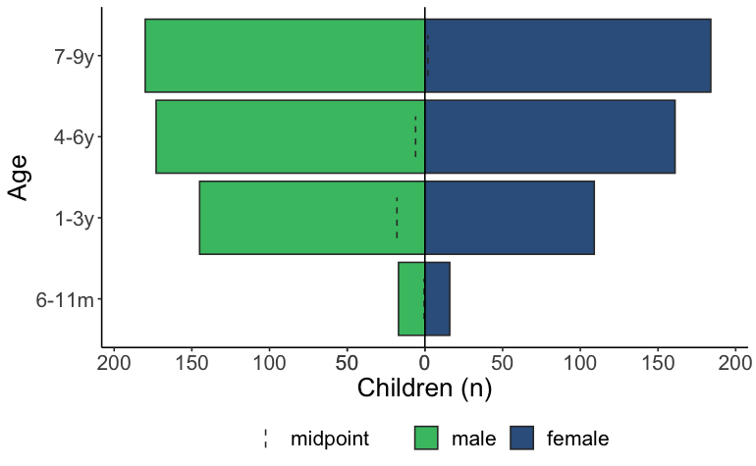

### Vaccination coverage – MSF Vaccination Campaign

Information on the MSF mass vaccination campaign was collected from 985 children aged 6 months to 9 years. The measles vaccination coverage among children in this age group was 95.8% (95% CI: 93.0–97.5). This was reported by respondents either by showing their vaccination card or by verbal confirmation (Table 3). The measles vaccination coverage among children who were able to show their vaccination card was 89.4% (95% CI: 84.2–93.1). The design effect for MSF vaccination is close to the expected value (2.5), indicating a moderate degree of heterogeneity between clusters.

Table 3. Measles vaccination coverage among children aged 6 months to 9 years during the MSF mass vaccination campaign in Béboto district, Logone Oriental province, Chad (weighted analysis)

| **MSF vaccination status** | **Children (n)** | **% (95% CI)** | **Design effect** |
| --- | --- | --- | --- |
| Yes – card and verbal | 937 | 95.8 (93.0--97.5) | 2.8 |
| No | 47 | 4.1 (2.4--6.9) | 2.8 |
| Don't know | 1 | 0.1 (0.0--0.6) | 0.7 |

Of the 937 individuals who received an MSF vaccination, most people (97.1%) reported receiving it in their own village.

### Reasons for non vaccination (MSF)

As outlined in Table 3, 4.1% (95% CI: 2.4–6.9) of children were not vaccinated against measles during the MSF mass vaccination campaign. The main reason for this was that the family was away during time of vaccination (n=39). Table 4 provides a detailed overview of the reasons for not vaccinating the child during the MSF vaccination campaign, including a breakdown of nine reasons listed as “other”.

Table 4 Reasons for not receiving measles vaccination during the MSF vaccination campaign in Béboto district (N=47)

| **Reasons for non-vaccination (MSF)** | **Count (n)** | **Percent (%)** |
| --- | --- | --- |
| Family was outside village during campaign | 39 | 83.0 |
| S/he was working during the campaign | 3 | 6.4 |
| Child was sick during vaccination campaign | 2 | 4.3 |
| Child already had measles | 1 | 2.1 |
| Didn't know child was eligible for vaccination | 1 | 2.1 |
| Not enough vaccine at the vaccination place | 1 | 2.1 |

### Vaccination coverage – routine Vaccination (9 months)

Information on routine vaccination status (i.e. the routine vaccination normally administered at 9 months of age) was collected from 985 children aged 6 months to 9 years. The measles vaccination coverage among children in this age group was 45.4% (95% CI: 35.0–56.1). This was reported by respondents either by showing their vaccination card or by verbal confirmation (Table 5). Most of the affirmative responses were through verbal confirmation; the measles vaccination coverage among children who were able to show their vaccination card was 2.1% (95% CI 1.1–3.9). The design effect for routine vaccination is much higher than the expected value (2.5), indicating a high degree of heterogeneity between clusters.

Table 5. Measles vaccination coverage among children aged 6 months to 9 years during routine vaccination at 9 months in Béboto district, Logone Oriental province, Chad (weighted analysis)

| **Routine vaccination status** | **Children (n)** | **% (95% CI)** | **Design effect** |
| --- | --- | --- | --- |
| Yes – card and verbal | 405 | 45.4 (35.0--56.1) | 11.1 |
| No | 417 | 38.6 (29.5--48.6) | 9.5 |
| Don't know | 160 | 15.6 (9.3--25.0) | 11.1 |
| No answer | 3 | 0.4 (0.1--2.6) | 3.4 |

Of the 405 individuals who received the routine vaccination, most people (78.8%) reported receiving it at the health centre in their health zone. The rest (21.2%) stated that they had to visit a site that was more than 5km away.

### Reasons for non-vaccination (routine)

Among surveyed individuals, 417 (38.6%) did not receive their routine vaccination against measles at 9 months of age. The primary reason for this (n=209) was that the family was not aware the child should be vaccinated against measles at 9 months. The next most common reason was re-classified as “no reason” (n=62) from the “other” free text category. The majority of responses that were classified as “no reason” had stated “I don’t know” as the response. Table 6 provides a detailed overview of the reasons for not vaccinating the child during routine vaccination, including a breakdown of 350 reasons originally listed as “other”.

Table 6. Reasons for not receiving measles vaccination during the routine (9 months) vaccination in Béboto district (N=417)

| **Reasons for non-vaccination (routine)** | **Count (n)** | **Percent (%)** |
| --- | --- | --- |
| Wasn't aware of routine vaccination | 209 | 50.1 |
| No reason | 62 | 14.9 |
| No answer | 36 | 8.6 |
| Family was outside of village at the time | 31 | 7.4 |
| Child was too young | 24 | 5.8 |
| Other | 12 | 2.9 |
| Lack of willingness | 10 | 2.4 |
| Vaccination took place too far away | 8 | 1.9 |
| Competing priorities | 5 | 1.2 |
| Not beneficial | 5 | 1.2 |
| Vaccines are not beneficial | 4 | 1.0 |
| Lack of follow up from health centre | 3 | 0.7 |
| Vaccine rupture | 3 | 0.7 |
| Didn't attend the appointment | 2 | 0.5 |
| Child was too old | 1 | 0.2 |
| No vaccination opportunity in the village | 1 | 0.2 |
| Painful | 1 | 0.2 |

### Vaccination coverage – supplementary vaccination activities (SIA)

Information on supplementary vaccination activities (SIA) was collected from 985 children aged 6 months to 9 years. The measles vaccination coverage among children in this age group was 48.0% (95% CI: 38.3–56.1). This was reported by respondents either by showing their vaccination card or by verbal confirmation (Table 7). Most of the affirmative responses were through verbal confirmation; the measles vaccination coverage among children who were able to show their vaccination card was 1.7% (95% CI 0.6–4.5). The design effect for SIA vaccination is much higher than the expected value (2.5), indicating a high degree of heterogeneity between clusters.

Table 7. Measles vaccination coverage among children aged 6 months to 9 years during other vaccination opportunities in Béboto district, Logone Oriental province, Chad (weighted analysis)

| **SIA vaccination status** | **Children (n)** | **% (95% CI)** | **Design effect** |
| --- | --- | --- | --- |
| Yes – card and verbal | 478 | 48.0 (38.3--57.8) | 9.3 |
| No | 377 | 39.6 (33.8--45.7) | 3.6 |
| Don't know | 122 | 12.4 (7.1--20.8) | 9.7 |
| No answer | 8 | 1.1 (0.3—3.4) | 3.6 |

Of the 478 individuals who received an SIA vaccination, 78% of respondents reported receiving it in their own village. Following that, 16.1% reported receiving it in a health centre. Because this question was entirely free text responses, it’s possible that some health centre responses could also be the same village the person lived in. A small number of people reported specific locations (e.g. 2.9% reported the village Betoyo as the vaccination site).

### Reasons for non-vaccination (SIA)

Among surveyed individuals, 377 (39.6%) did not receive vaccination against measles during any other supplementary immunization activity. Most respondents (n=187) stated the reason for this was that the child was not yet born or was too young to receive a vaccine when a campaign occurred. The next most commonly cited reason (n=83) was that there was no vaccination campaign that had occurred. See Table 8 for a detailed breakdown of reasons for not vaccinating a child during supplementary immunization activities, including 295 responses that were originally listed as “other”.

Table 8. Reasons for not receiving measles vaccination during the SIA in Béboto district (N=377)

| **Reasons for non-vaccination (SIA)** | **Count (n)** | **Percent (%)** |
| --- | --- | --- |
| Child not yet born/ too young | 187 | 49.6 |
| No vaccination campaign took place | 83 | 22.0 |
| No answer | 25 | 6.6 |
| Didn't know child was eligible for vaccination | 22 | 5.8 |
| Family was away during time of vaccination | 21 | 5.5 |
| Unaware there was a vaccination campaign | 20 | 5.3 |
| No reason | 15 | 4.0 |
| Vaccination site was too far away | 2 | 0.5 |
| Child was in the care of someone else | 1 | 0.3 |
| Child was too old | 1 | 0.3 |

### overall measles vaccination coverage

To calculate overall measles vaccination coverage in Béboto district, all vaccination opportunities were taken into account for the 985 children aged 6 months to 9 years. The overall vaccination coverage among children in this age group was 98.1% (95% CI: 96.3–99.1), which was reported by respondents either by showing their vaccination card or by verbal confirmation (Table 9).

Table 9. Overall measles vaccination coverage among children aged 6 months to 9 years in Béboto district, Logone Oriental province, Chad (weighted analysis)

| **Overall vaccination status** | **Children (n)** | **Vaccination coverage (95% CI)** | **Design effect** |
| --- | --- | --- | --- |
| Vaccinated | 964 | 98.1% (96.3--99.1) | 2.2 |
| Not vaccinated | 21 | 1.9% (0.9--3.7) | 2.2 |

Figure 2 presents the vaccination coverage among children aged 6 months to 9 years by the different vaccination opportunities, and the overall vaccination coverage for measles in Béboto’s 13 health zones where the MSF vaccination campaign and coverage survey took place.

Figure 2. Measles coverage by vaccination opportunity among children aged 6 months to 9 years in Béboto district, Logone Oriental province, Chad (weighted analysis)

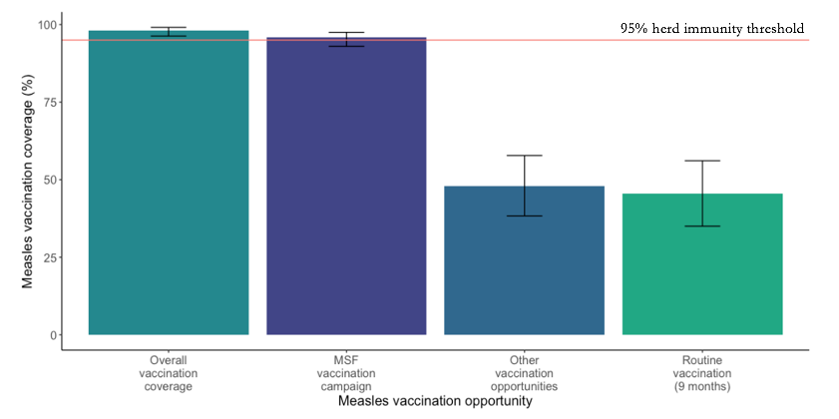

### Number of doses

Based on vaccination history, 23.1% (95% CI: 20.62–25.88) of children reported receiving three or more doses of measles containing vaccine in their life (either verbally or through confirmation by card). In addition, 2.1% (95% CI: 1.40–3.24) reported never receiving a dose of measles containing vaccine (Table 10).

Table 10. Total number of doses of measles containing vaccine for children aged 6 months to 9 years received based on three vaccination opportunities in Béboto district, Logone Oriental province, Chad (N=985)

| **Number of doses** | **Children (n)** | **% (95% CI)** |
| --- | --- | --- |
| 0 doses | 21 | 2.1 (1.40--3.24) |
| 1 dose | 336 | 34.1 (31.22--37.13) |
| 2 doses | 400 | 40.6 (31.22--37.13) |
| 3 or more doses | 228 | 23.1 (20.62--25.88) |

### Previous measles infection

Information on previous measles infection (as reported by caretaker) was collected from 985 children aged 6 months to 9 years. Of those children, 21.5% (95% CI: 16.4–27.6) reported previously having measles.

Of the children who reported previously having measles, the median age the child became ill was 4 years. However, 747 (75.8%) individuals were missing information on age in this category.

Table 11. Previous measles infection among children aged 6 months to 9 years in Béboto district, Logone Oriental province, Chad

| **Previous measles infection** | **Children (n)** | **Percent (95% CI)** |
| --- | --- | --- |
| Yes | 238 | 24.2% (21.6--26.9) |
| No | 718 | 72.9% (70.0--75.6)) |
| Don’t know | 29 | 2.9% (2.0--4.2) |

Based on overall vaccination history and previous measles infection (as reported by the caretaker), the estimated immunity in children aged 6 months to 9 years is 98.7% (95% CI: 97.5–99.4).

Table 12. Immune status among children aged 6 months to 9 years in Béboto district, Logone Oriental province, Chad

| **Immune status** | **Children (n)** | **Immunity (95% CI)** |
| --- | --- | --- |
| Immune | 971 | 98.6% (97.6--99.2) |
| Susceptible | 14 | 1.3% (0.9--2.4) |

## Discussion

The vaccination coverage survey indicates that the MSF vaccination campaign achieved 95.8% vaccination coverage (95% CI: 93.0–97.5) for children aged 6 months to 9 years in Béboto district, Logone Oriental Province, Chad. This level of coverage provides the population in that age group with herd immunity, protecting them from measles outbreaks in the region, and reducing morbidity and mortality associated with the disease. However, high levels of routine vaccination will be required to prevent future outbreaks

Because the vaccination coverage survey was conducted directly following the MSF vaccination campaign in Béboto, this likely reduced recall bias regarding whether or not the child had been vaccinated and reasons for non-vaccination. In addition, many respondents were able to produce their vaccination card as confirmation that their child had received the vaccination.

The coverage for routine vaccination was low at 45.4% (95% CI: 35.0–56.1). The overwhelming reason cited for non-vaccination was that the caregiver was unaware that children should receive routine vaccination at nine months. According to the most recent UNICEF data on Chad, only about 22% of women give birth in a health facility,[7] which means that the majority of women in Chad are giving birth at home. Furthermore, only about 20% of deliveries in Chad are attended by a skilled birth attendant.[8] Women who give birth at home, without a skilled attendant, may not receive valuable information related to the health of their child, such as the importance of getting routine vaccinations at nine months. This appointment also includes vaccination against other diseases such as yellow fever, tetanus, mumps, and others, so coverage for these diseases may also be low. Additional awareness-raising activities in Béboto would be extremely beneficial in order to inform parents and caretakers about this health milestone.

Still, even if parents or caretakers were better informed, it’s uncertain whether they would have sufficient access to routine vaccinations for their child. The low coverage from the supplementary immunization activities combined with a lack of concrete information on previous mass vaccinations organized by the Ministry of Public Health indicate a poorly functioning Expanded Programme on Immunization (EPI).

Coverage for other measles vaccination opportunities opportunities was low, at 48% (95% CI: 8.3–57.8). The main reason provided by caretakers for non-vaccination was that the child was either too young or not yet born when a vaccination opportunity occurred in their village (n=187). There is no definitive information on exactly when the last mass measles vaccination campaign took place in Béboto district; the last national campaign took place in 2015, but there is data suggesting vaccination campaigns took place since then, in 2016 and 2017. If that’s the case, with 59.3% of children in this study aged five or older (i.e. able to be vaccinated in the last five years), we would hope to see a slightly higher vaccination coverage. This discrepancy is difficult to interpret, but two possibilities are that: 1) there is a lack of awareness about one or more vaccination campaigns that took place in Béboto; or 2) no vaccination campaign took place in recent years. More concrete data on previous vaccination campaigns in Béboto would be helpful in better understanding this result.

The design effects for routine vaccination coverage and supplementary immunization activities coverage were high (11.1 and 9.3 respectively), indicating a high degree of heterogeneity between clusters. This could be explained by a more proactive vaccination approach in certain health zones. For example, in Bekoura health zone (where coverage was higher), the health centre manager travels to faraway villages to vaccinate children. Other possibilities include: differing levels of sensitization among villages, or differing levels of care offered by health centres, including ability to store and administer vaccines.

Based on vaccination history, 336 children (34.1%, 95% CI: 31.22–37.13) reported receiving only one dose of measles containing vaccine in their lifetime (either verbally or through confirmation by card). Of that number, 316 – the large majority – received the vaccine during the MSF campaign.

Although 21.5% of children had a previous measles infection (as reported by the caretaker), most of the respondents did not know (or left blank) the age the child fell ill. This makes it difficult to know whether the child fell ill during the recent outbreak or if this was an earlier illness, because measles is endemic in Chad and overall vaccination coverage before the MSF campaign was low. However, when combining children with a previous measles infection with overall vaccination coverage, we find an immunity of 98.7% (95% CI 97.5–99.4) for children aged 6 months to 9 years in Béboto district.

The MSF vaccination campaign played a vital role in providing Béboto district with sufficient coverage to protect children aged 6 months to 9 years from measles for the time being. Without it, coverage would not have been close to the 95% required to achieve herd immunity, and the population would have remained at risk. However, the lack of knowledge about routine vaccination (and potential unavailability of routine vaccination opportunities) as well as few or irregular supplementary immunization activities, and a high birth rate[9], we can expect to see another outbreak in next two to four years if routine vaccination and supplementary immunization activities are not improved.

### limitations

There were some limitations to the study that should be noted. First, recall bias may have occurred as respondents were asked to remember details about routine vaccination at 9 months of age as well as any other supplementary immunization activities that occurred during the child’s lifetime. Depending on the age of the child, this could have been long ago. In addition, parents or caretakers could have confused other mass vaccination opportunities that occurred in the district (e.g. meningitis) with a measles campaign, leading to misclassification bias in the SIA results.

The study examined whether a child had been previously infected with measles. However, it’s possible that the parent or caretaker assumed the child was previously ill with measles when they had a different illness with similar symptoms. This study accepted all reports of previous measles infection, not just those that were medically confirmed, so immunity of the population may have been slightly overestimated. However, given that most of the population’s immunity was because of the MSF vaccination, a child’s history of measles infection did not greatly impact this result.

As noted in results section 2.1, the total number of households visited was 438, with four households unaccounted for in Table 1. One possible reason for this is data entry error. During the survey, it was noticed that teams did not always enter data into the tablet when they encountered a house that they would not interview (e.g. no children aged 6 months to 9 years in the household). When this occurred, teams replaced the household per the study protocol, but occasionally neglected to enter the household into their tablet. However, they were more diligent in noting occasions like this on the paper forms they used to assist with household numbering. This is evidenced by the fact that the electronic data show 75 households without eligible children, but the paper forms show 85. However, the paper forms were not created with the intention of tracking households without eligible children, and it was only possible to calculate because teams spontaneously added it to the notes section. So ultimately, even 85 may be an underestimate, and the true number of households without empty children may have been 89. To avoid this, future vaccination coverage surveys may want to either add more detail to the paper forms, or, preferably, focus on increased training and close supervision of study interviewers regarding entering household data into tablets even if they’re being excluded. Having all data already in electronic format makes for easier and more reliable data analysis later, if the data entry was done well to begin with.

## Recommendations:

* Routine vaccination is an essential milestone, especially given persistent measles outbreaks across Chad. Yet, the population of Béboto was overwhelmingly unaware of the need to take their child for a routine vaccination at 9 months. Improved and widespread sensitization activities are recommended, taking care to reach those who are likely to give birth at home.
* Chad’s EPI activities need to be improved, as coverage before the MSF vaccination response in Béboto only offered protection to approximately 50% of the population aged 6 months to 9 years; far below the level required for herd immunity. More frequent SIAs are required, as most respondents reported that their child was too young or had not yet been born when the last SIA campaign occurred in Béboto.
  + An important step to improving EPI is understanding where the gaps and weaknesses lie. An evaluation of the ministry of health’s immunization program is suggested to identify areas for improvement (e.g. supply chain, cold chain, transport, human resources).

1. UNdata: country profile | Chad. 2019. Available at: http://data.un.org/en/iso/td.html
2. United Nations Development Programme. Chad. Available at: http://hdr.undp.org/en/countries/profiles/TCD
3. Henderson RH, Sundaresan T. Cluster sampling to assess immunisation coverage: A review of experience with simplified sampling methodology. Bulletin of the World Health Organization 1982(60):253-60
4. Note that WHO guidance on sampling has been updated since the 2005 Coverage Cluster Survey: Reference Manual – Please refer instead to Annex B1 of the 2015 reference manual (footnote 4 below)
5. Council for International Organizations of Medical Sciences (CIOMS). International Ethical Guidelines for Biomedical Research Involving Human Subjects. CIOMS Geneva 2002. http://www.cioms.ch/index.php/publications/printablev3/541/view_bl/65/bioethics-and-health-policy-guidelines-and-other-normative-documents/19/international-ethical-guidelines-for-biomedical-research-involving-human-subjects?tab=getmybooksTab&is_show_data=1.
6. Council for International Organizations of Medical Sciences (CIOMS). International Ethical Guidelines for Epidemiological studies. CIOMS Geneva 2009. <http://www.cioms.ch/index.php/publications/printablev3/541/view_bl/65/bioethics-and-health-policy-guidelines-and-other-normative-documents/47/international-ethical-guidelines-for-epidemiological-studies?tab=getmybooksTab&is_show_data=1>.
7. UNICEF Data: Monitoring the situation of children and women. 2015. Available at: https://data.unicef.org/country/tcd/
8. UNICEF Data: Monitoring the situation of children and women. 2015. Available at: https://data.unicef.org/country/tcd/
9. # Fertility rate, total (births per woman) – Chad. 2018. Available at:

   https://data.worldbank.org/indicator/SP.DYN.TFRT.IN?locations=TD